# Cybersecurity

## Activity 1.2.2: File Management

Copy and paste screenshots and/or answer questions from the activity.

#6 To open the Welcome file, double-click it. Describe what happened.

Get a message saying its an executable

#7 Double-click to open the ImportantMessage1 file. Describe what happened.

Terminal opens saying a file has been executed

#14 Screenshot-- Change the extensions of each file so they seem to have two extensions:

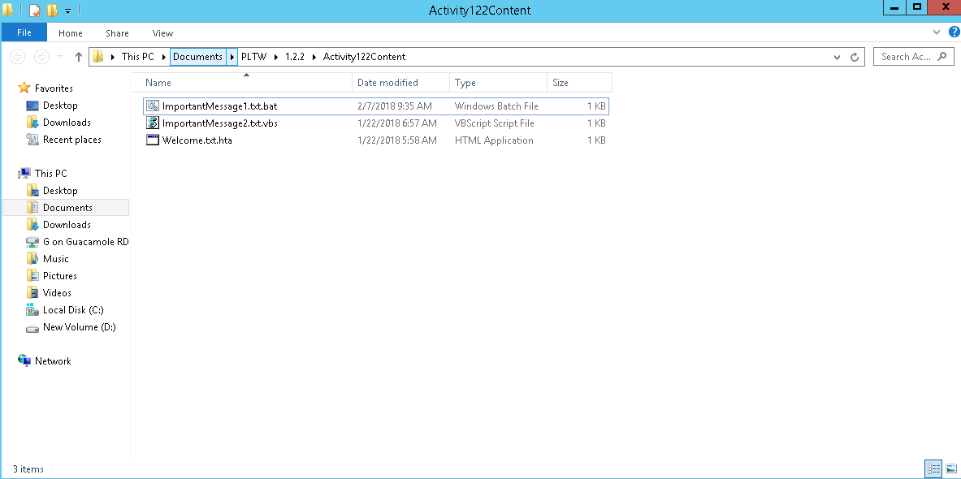

#17 Can you find a clue or hint that the .txt files are not actually text files?

Under “Type” it tells you the kind of file

#20 What’s the username?

WIN2012R2\Administrator

#21 Record the owners of the various files and folders. This begins a list of “Trusted Users”

of your computer; add your user name to the list.

WIN2012R2\Administrator

SYSTEM

TrustedInstaller

Administrators

#24 Screenshot

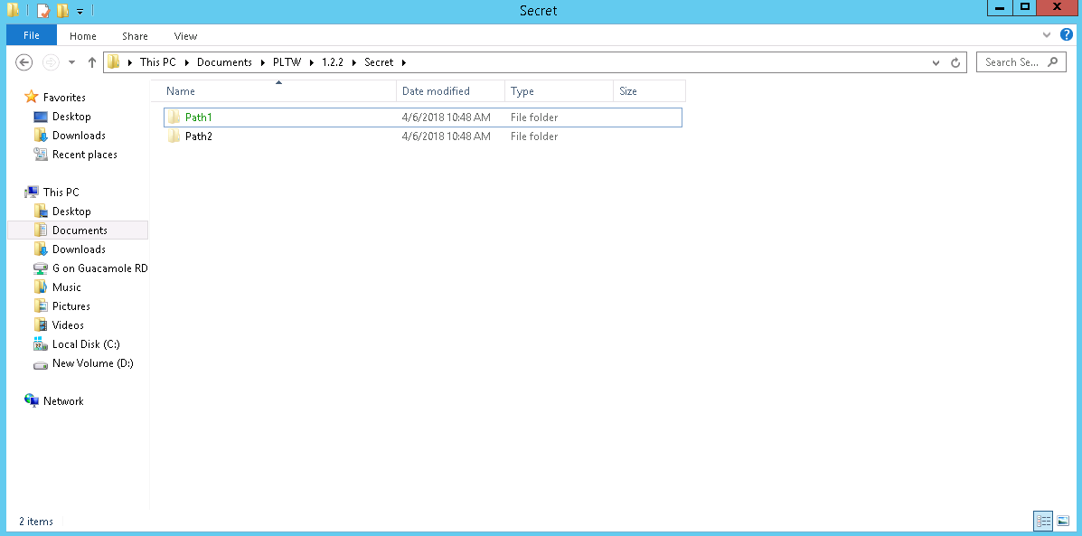

#27 Screenshot and describe how to do a wildcard search and what it does.

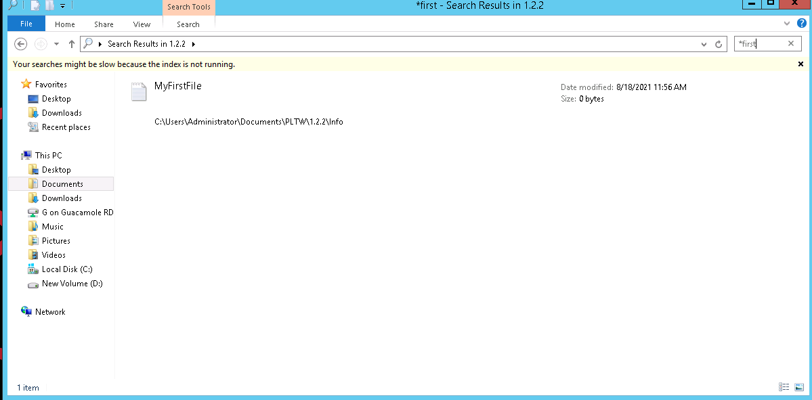

A wildcard search includes one of the special characters which indicate a specific function to apply when searching. By typing “*” in front of any word in the search box you can find files & folders with the following word anywhere within the items name

#29 Screenshot

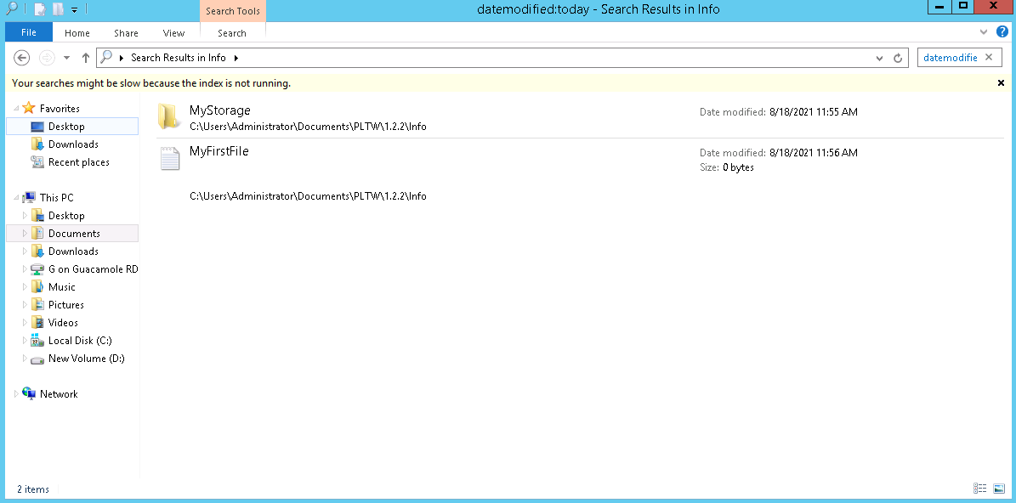

#30 Screenshot

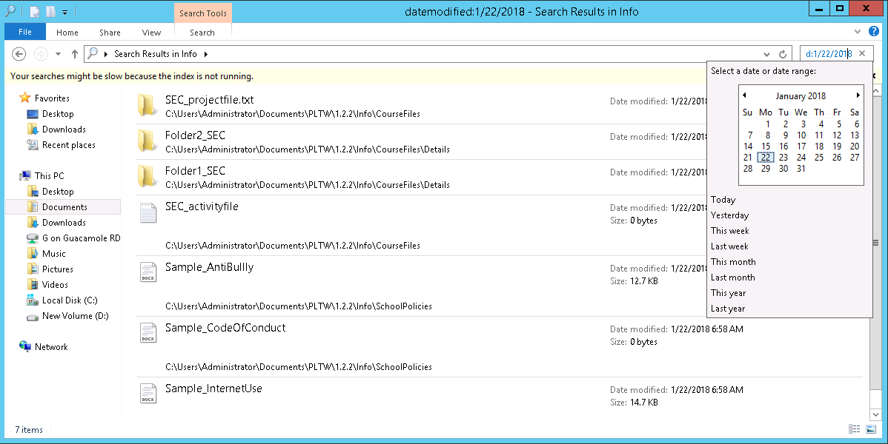

#33 Screenshot

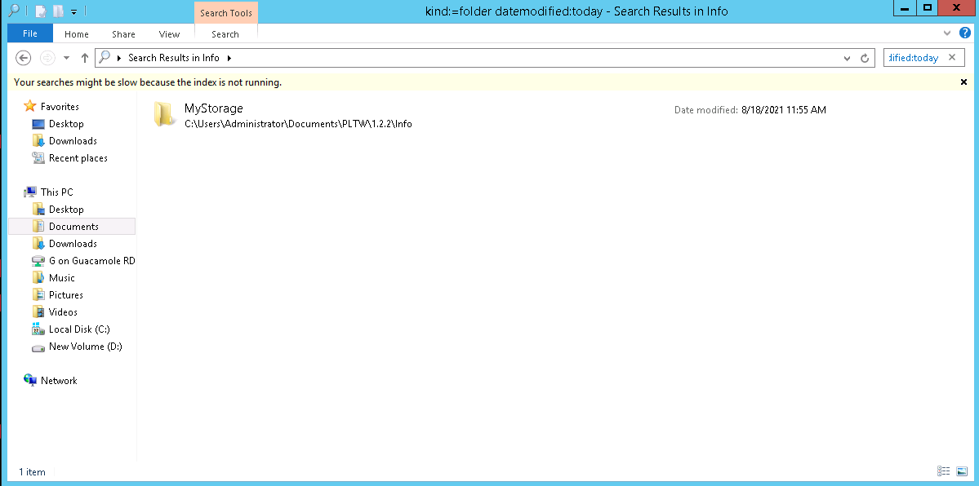

#34 Screenshot results of the following:

1. Search for folders (only folders) with “SEC” in any part of the name.

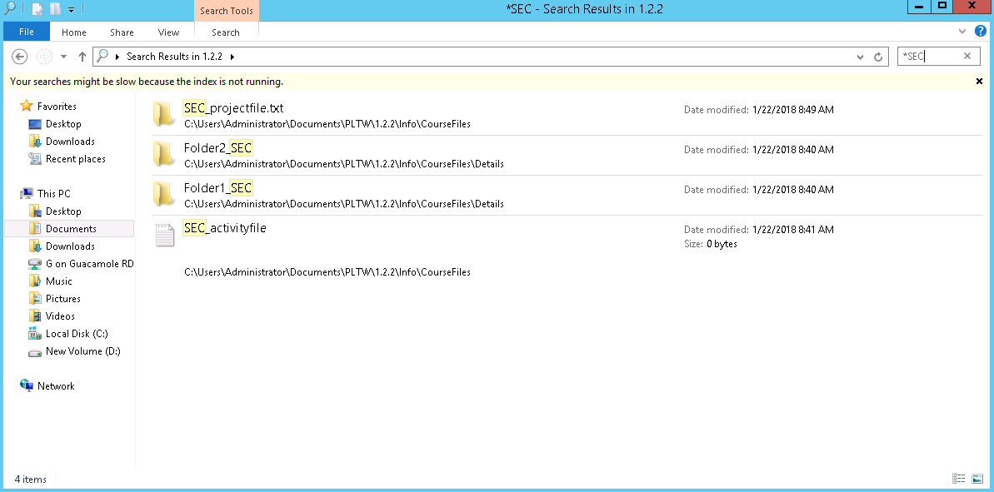

1. With a wildcard, specify all items. This should show all files and folders, in this folder and all subfolders.



1. Search for items that have the word unknown somewhere in their name.

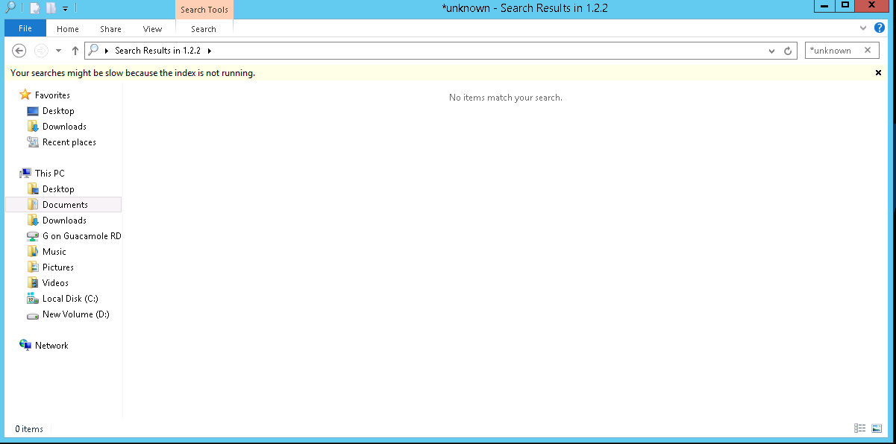

#35 Screenshot results of the following:

1. Find all executable script files that have file extensions such as .bat, .hta, or.vbs.

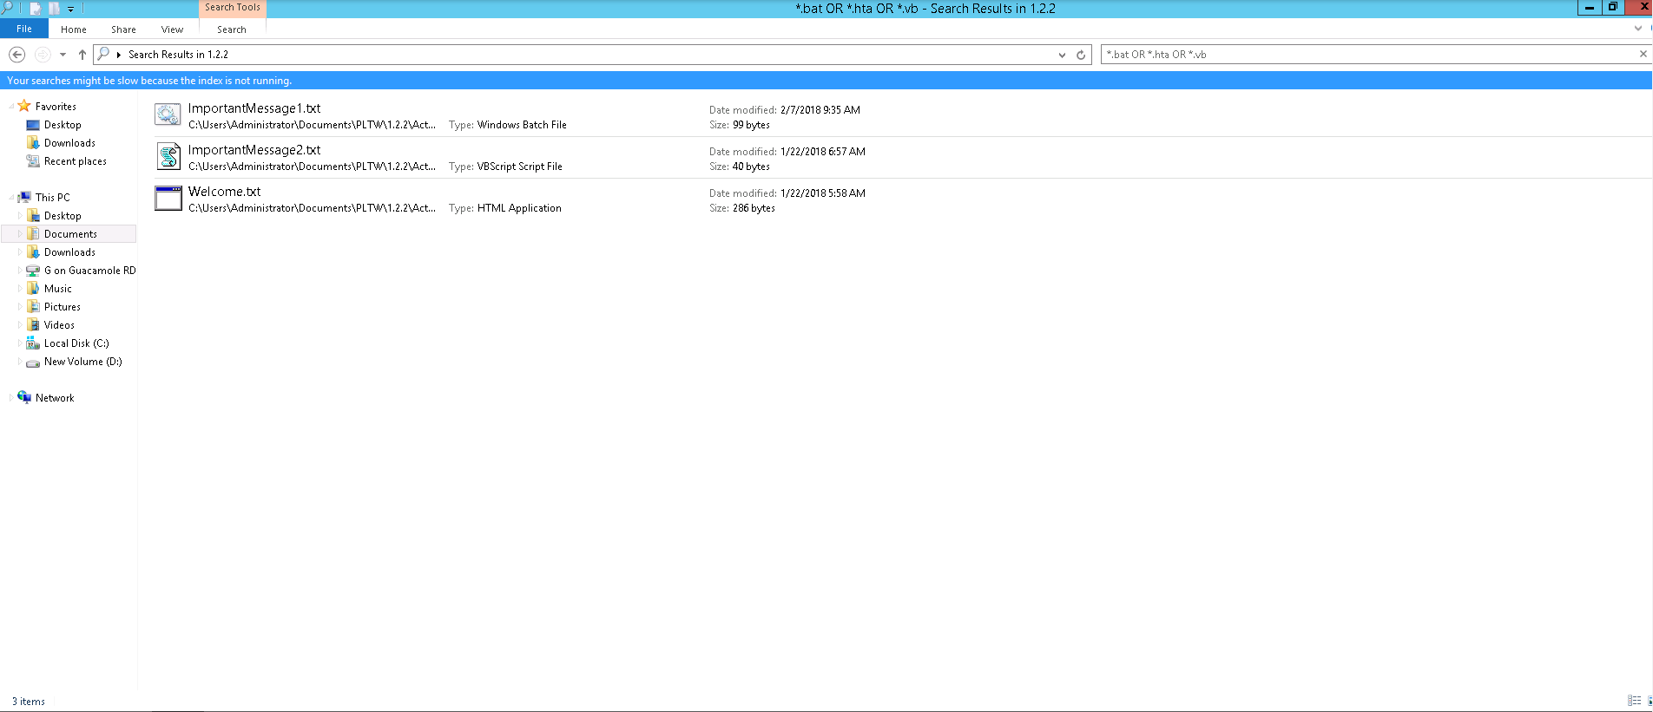

1. To get the opposite results, you can add a NOT to a search. Use the NOT option to search for everything except folders

